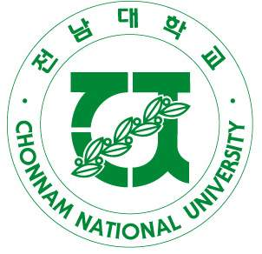 | Chonnam National University  77 Yongbong-ro, Buk-Gu Tel: +82-62-530-1273  Gwangju, South Korea 500-757 Fax: +82-62-530-1269  E-Mail: shannon@chonnam.ac.kr

Visiting Scholar Application for CNU-ISS 2012

Return to: Deadline for Application: December 31st 2011
Office of International Affairs
Chonnam National University
77 Yongbong-ro, Buk-gu
Gwangju, 500-757 S. Korea

- Family Name ________________________ Given Name__________________________

Gender (please circle): Male / Female

2. Place of Birth: ___________________________________ Date of Birth ___________________

3. Citizenship (nation from which passport is obtained) ____________________________________

4. Present title as faculty member ___________________________________________________

5. University: Department:

6. Office address: ________________________________________________________________

7. Telephone: _______________________________ Fax: _______________________________

8. Email: _______________________________________________________________________

9. Preferred Surface Mail Address: ___________________________________________________

10. Colleges & Universities Attended Principal subject Dates of study Degree & year awarded

___________________________ ____________ ___________ __________________

___________________________ ____________ ___________ __________________

___________________________ ____________ ___________ __________________

11. Previous fellowships, scholarships, grants, and other honors______________________________

______________________________________________________________________________________

______________________________________________________________________________________

______________________________________________________________________________________

12. List all positions, academic or other, in chronological order, with dates, including the date from which you have held your present faculty position:

________________________________________________________________________________

________________________________________________________________________________

________________________________________________________________________________

14. Publications where applicable. Please list titles in the original language as well as English.
Attach a separate bibliography

________________________________________________________________________________

________________________________________________________________________________

________________________________________________________________________________

15. Indicate course titles and brief syllabus of what you are willing to teach in CNU-ISS

________________________________________________________________________________

________________________________________________________________________________

________________________________________________________________________________

17. List any Faculty member(s) you know at Chonnam National University.
Name Department Field
__________________ ___________________________ ___________________________

__________________ ___________________________ ___________________________

18. State details of family members traveling with you.

Name Relationship Age
__________________ ___________________________ ___________________________

__________________ ___________________________ ___________________________
__________________ ___________________________ ___________________________

19. Miscellaneous Comments or Information:

For an electronic version of application forms and with further enquiries, please email Shannon Shinhye Kang at shannon@jnu.ac.kr with any questions regarding Chonnam National University International Summer Session.

